MG US Operations – MGL Inc

Business

The financial services division, MGL Inc, is split into 2 areas:

- FCM (Futures Clearing Merchant) where MGL Inc is registered as a CTA (Commodities Trading Advisor) with the CTFC and NFA. The firm does not take on proprietary positions.

- IB (Introducing Broker) Business for MGL on LME OTC trades.

Futures Clearing

Regulation & Capital

MGL Inc is a member and a clearing member of COMEX and NYMEX. It is also a non-clearing member on all other US futures & options exchanges. Regulation is carried out by the NYMEX in its position as a Designated Self-Regulated Organisation (DRSO). The NYMEX requires the company to hold capital of $28m (CFTC requirement is only $250K). This is the responsibility of MGL Inc and was initially funded by $20m of sub debt from MGNA (which is not part of MG plc) five years ago. The ongoing availability of this debt will need to be examined.

At present no activity is carried out on the NYMEX, as the Aluminium contract there does not have sufficient liquidity. The ability to provide service on the NYMEX is retained.

Potential Synergy: If MGL Inc was to be used purely for clearing purposes (i.e. remain with existing brokers) by Enron Global Products then MGL Inc management stated that it would be able to deal with the volume without additional resource. This would have the benefit of having only MGL Inc knowing Enron’s position. Costs would be expected to be approximately 50 cents per lot. An important issue would be a requirement to increase the capital in the company however. Their estimate of the additional capital required is $20m sub debt and $40m of unconditional guarantee.

Action Points:
- Highlight existing capital structure to Global Finance (Anne Edgely)
- Highlight this to Global Products management (Tim Poullain-Patterson) and provide introduction to Al Pennisi if requested.

Market

98% of the business carried out is for MG plc group companies. The remaining 2% is focused on 10 to 12 commercial customers, the three largest being Ansam, Transworld and Wise Metals. Trading on the COMEX is margined with cash (or T-Bills) on a daily basis.

Additional functions

The operations section of MGL Inc is responsible for providing Net Asset Values (NAV) for the MG Metal fund located in Guernsey (MGMF).

Introductory Broker

Market

The target customer base is the major producers and users. In addition to providing market making and brokerage services the US operation runs the arbitrage book. The majority of trades are 3month prompt.

The P&L for the US operations is commissions, however the book in London has P&L driven by:
- Arbitrage book (a sub-book of the London P&L but maintained separately on a spreadsheet in NY as well)
- Options
- Spread
- MGL Inc is one of the largest market participants on the alloy market

The NY business starts at 6am and takes on the MITS book at 2pm New York time.

Control

Futures Clearing

All activity is carried out by one of Al Pennisi’s operation team (3 people) unless otherwise indicated.

Deal Entry

Top day trades are reconciled to the exchange screens on a trade by trade basis prior to being sent to the Rolfe & Nolan (R&N) system (development is being looked at that will allow automatic download from the NYMEX system into R&N – this is of relevance only if NYMEX clearing is carried out).

A review is carried out of commissions, adjustments and securities and deposits in R&N daily to ensure that the systems has processed transactions correctly.

For COMEX trades carried out on behalf of MGL as well as entering into Rolfe & Nolan for MGL Inc’s clearing services these also entered into the AS400 on behalf of MGL. Details are entered from the trading ticket provided to the operations team.

NB all phones are taped.

Logistics

Where futures trades go to delivery (i.e. the underlying warrant) this is covered by MGL Inc. In the instance where MGL is taking delivery of the warrant a certified cheque is raised on behalf of MGL Inc and the warrants received in bearer (paper) form. Al Pennisi collects these warrants and is accompanied by one other person when doing so. The warrants may be traded or taken to the warehouse for physical delivery of the underlying metal.

The office typically has 200-300 warrants on site, each with a face value of approximately $22,000, a total value in excess of $0.5m. The maximum held at any one time has been 1,000 resulting in a total value in excess of $22m. These warrants are kept in a safe in the office.

Options are typically closed out and so rarely go to delivery.

Accounting / Reconciliations

Cash flows for margins & commission data is downloaded using a floppy disk and entered into R&N. These are reconciled to the electronic statement from Chase Manhattan daily. Entry of the cash flows into SAP is carried out in the accounting group under Louis Colarusso.

In the few instances where outside brokers (e.g. ABN Amro) are used for products that MGL Inc doesn’t clear, the balances are reconciled daily. In addition balances with the exchange are reconciled daily and posted into SAP. This allows a balance sheet approach to be used to daily P&L verification.

Annually the 1099 is prepared for the tax department. Next return due Jan 2001.

Production of financial reports for the business is carried out by Lisette Farrah in the accounting team under Louis Colarusso. This includes monthly independent bank reconciliations.

Commission are entered into SAP monthly and invoiced to London.

Margining/Cash management

As part of the control of the capital of the firm Al Pennisi produces a capital report daily. This summarises:
- Cash in.
- Cash out.
- Cash available for inventory.
- Cash available for mid-day margin calls.
- Excess over exchange requirements.

Overall responsibility for managing the cash flows of MGL Inc lies with Al Pennisi. As part of ensuring that the business gets the maximum return on its funds on the overnight market the operations team buys & sells T bills as part of the margining activity as these are allowable in place of cash. Margin calls are made to customers (internal & external) via phone. All cash movements are authorised by one of the operations team and actioned by the cash management team working for Harry Zlotnick.

Customer Statements

Customer statements are produced by the R&N system. These are reviewed for correct cash and deal entries prior to being sent out.

Regulation

Al Pennisi is responsible for ensuring that regulatory requirements are met. These include:

- Capital requirements.
- Segregation of client funds. The CFTC also require client account reporting. The operations team produces a Segregated report, signed off by Al Pennisi, to meet this.
- NYMEX (as the DSRO) and the CFTC require reports on margin calls and positions and limits. These are supplied by the operations group.
- Completeness of records – all trade tickets should be time stamped.
- Production of “Give up agreements” for cancelled trades.
- Customer disputes.

There have been over 12 visits from the CFTC and the DSRO over the last four years, from which no material issues have been raised. AA should have copies of these – obtain prior to any detail analysis.

Administration

Creation of new customers is carried out with Hamish Scutt (Credit Manager) in London. Margin limits are set so that exposure to margin calls does not present an excessive risk to the business.

MGMF

Book keeping functionality for the fund is provided by HCBC in Guernsey, Control of the fund is by Craig Young who splits his time between London and New York. Al Pennisi provides the MTM data to them so that they can calculate unit values. The current value of this fund is circa $869,000 and is made up principally of futures. Management of the fund will be discussed with Craig Young in London.

Conclusions

From the limited review carried out there do not appear any major procedural risks. The storage of bearer bonds on site has the potential to expose the business to losses.

Action Points:
- Discuss features of COMEX warrants with Tim Poullain-Patterson and ascertain whether this is an actual risk (ability to fraudulently use stolen bearer warrants may be limited).
- Raise issue of $20m sub debt from MGNA with Anne Edgely.

Introductory Broking

Limits

The business in NY is agency for MGL and hence all positions are controlled out of London including market making. London predefines limits. Any trading beyond pre agreed limits must be cleared with London first – they may be contacted out of hours.

Deal entry and confirmation

Deal tickets are raised in New York and faxed to London at the end of the day. London then:

- Enter deal into AS400.
- Produce the deal confirmations.
- Send out the confirmations with e-mail copy to New York.

New York checks the e-mailed confirmations against the traders’ blotters.

The positions being run for the arbitrage book, which is run in New York, are also maintained in parallel on a spreadsheet in NY. NB these are a subset of the London book in the AS400 and hence fall within the overall limit & control structure for MGL.

Customer confidentiality

All customers are identified by code names in the trading systems to maintain client confidentiality.

Pricing

MGL Inc is responsible for entry of all US prices into the AS400. This includes:
- COMEX trades
- Silver
- Gold
- Palladium
- Platinum

Logistics

The London side of the business handles physical delivery of warrants.

Conclusions

The agency nature of the business should mean that exposure to operational risks is acceptable as the ability of traders to commit the firm is limited given the middle and back office functions being in London. The checking of confirmations to traders’ blotters should minimise the potential for incorrect recording of risk by the London operations. Ultimately, satisfactory control is dependent upon effective limit monitoring in the London office and trader attitude to obtaining permission for additional trading limit out of London hours. This will be looked at by the RM review by Lloyd Fleming.

A full walkthrough of a trade booking would allow detail control issues to be identified.

Organisation

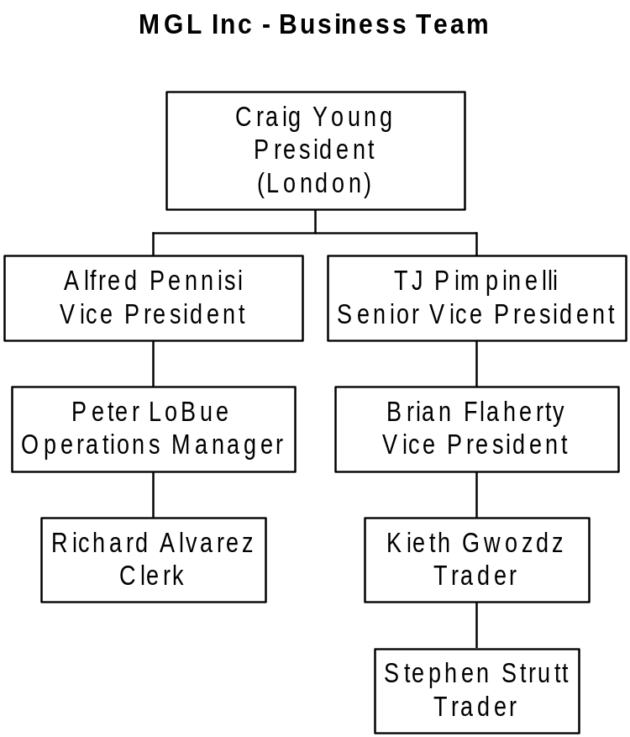

This IB business is an agency for London and hence overall control lies with Tim Jones in London.

Systems

Futures Clearing

R&N is the principal system used for both accounting and operational aspects (producing statements etc). The back office side uses the same SAP accounting set-up as the rest of the local business in New York.

Rolfe & Nolan is a publicly listed company that provides systems solutions to a large part of the investment banking community. Details of the firm and products can be found at http://www.ranincusa.com/

Introductory Broking

Deal input is limited to COMEX trades and prices into the AS400. This system is being covered in detail by a London based review.

